SWITCHING BASICS

Q1. Open Cisco Packet Tracer or any network simulator, create a simple network with one switch and two PCs, and use the 'show mac address-table' command to observe how the MAC address table is initially empty.
Ans. I observed that the table was empty.
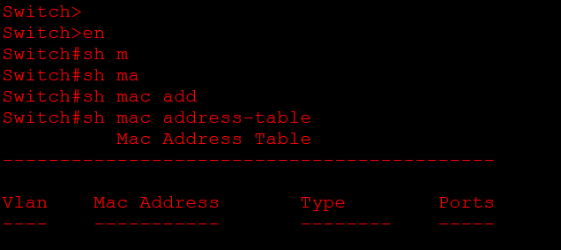
Q2. Send a ping from PC1 to PC2 in your simulated network, then immediately run 'show mac address-table' on the switch and note how the MAC addresses of both PCs appear in the table. Hint: Try pinging in both directions to see how the table updates.
Ans. After using ping command the switch captures mac address of bot pc the sender and the receiver.
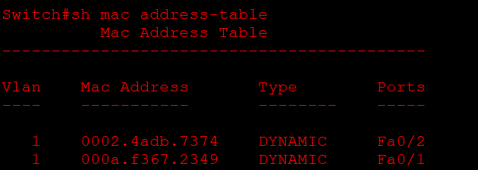
Q3. Add a third PC to your network, connect it to the switch, and ping from PC3 to PC1. Observe and record how the MAC address table changes after this communication.
Ans. After adding the third pc and pinging it to PC1 switch captures the mac address of PC1 and PC3 only.
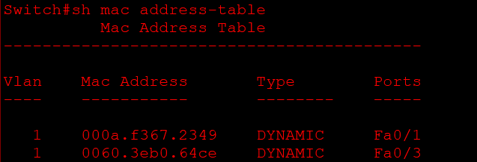
Q4. Suppose you see the following MAC address table on a switch: Port 1 - 00:11:22:33:44:55, Port 2 - 66:77:88:99:AA:BB. If a frame arrives at the switch on Port 1 with destination MAC 66:77:88:99:AA:BB, explain step-by-step how the switch will forward this frame.
Ans. Practical: MAC Address Table and Frame Forwarding
Objective: To understand how a switch forwards frames using its MAC address table.
Given MAC Address Table
Port | MAC Address
Port 1 | 00:11:22:33:44:55
Port 2 | 66:77:88:99:AA:BB
Step-by-Step Frame Forwarding
Step 1: The switch receives a frame on Port 1 with destination MAC address 66:77:88:99:AA:BB.
Step 2: The switch checks its MAC address table to identify the port associated with the destination MAC address.
Step 3: The switch finds that MAC address 66:77:88:99:AA:BB is connected to Port 2.
Step 4: The switch forwards the frame directly from Port 1 to Port 2 without sending it to other ports.
Step 5: The device connected to Port 2 receives the frame.
Conclusion: The switch uses its MAC address table to forward the frame directly to Port 2. This process is called unicast forwarding, which reduces unnecessary network traffic and improves network efficiency.
Q5. Draw a diagram showing how a switch learns and uses MAC addresses to forward frames in a network with 4 devices, and write a short explanation (3-4 sentences) describing the process in your own words. Constraint: Do not copy definitions from the textbook; use your own understanding and examples.
Ans.
